**COMP1004 – Rapid Application Development Assignment 3: Movie Bonanza - External Documentation**



By: Kevin Kan

Date: Nov, 14 2013

Table of Contents

Application Description: 1

Wire Frame: 1

Code Planning: 2

MultiMedia: 3

# 

# Application Description:

This program is a multiform program that simulates a streaming movie program where the user selects a movie from the drop down list. When a movie is selected the appropriate preview will display. The preview will display a movie poster and the cost to “stream” the video. The cost is determined by the movie’s category. There is an exit button that will close the application.

The user may select to go on to the next form only if they made a movie selection (Order Form) which will summarize the previous form’s information and will tabulate a cost for the streaming including tax. The form will also offer a purchase DVD that will add $10 prior to tax calculations. At this point this form will have a cancel button and menu that will cancel the transaction and close this form and revert back to the main selection form. This form will also have a menu that prints the summary as well as a stream button and menu item that starts streaming the video. The final menu item is a help -> about option that opens an about box.

If the user decides to proceed with streaming the video, the final form displays and thanks the user for choosing this service. It also says the user will be charged whatever final total was displayed and that the movie (by name) the user selected will begin streaming shortly.

# Wire Frame:

Splash Page

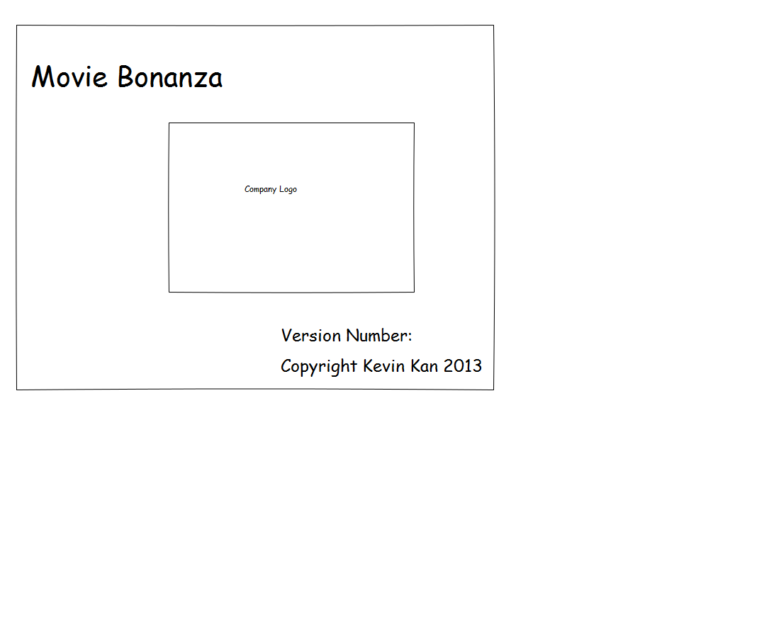

Selection Form

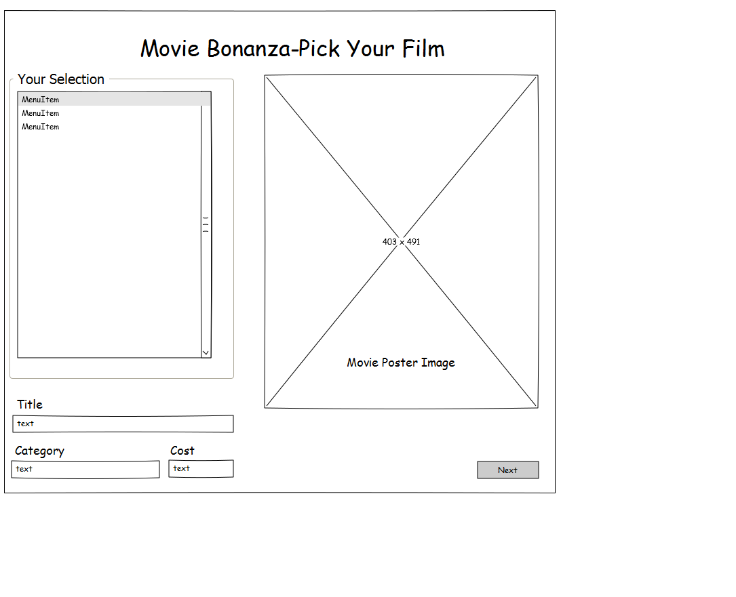

AboutBox Form

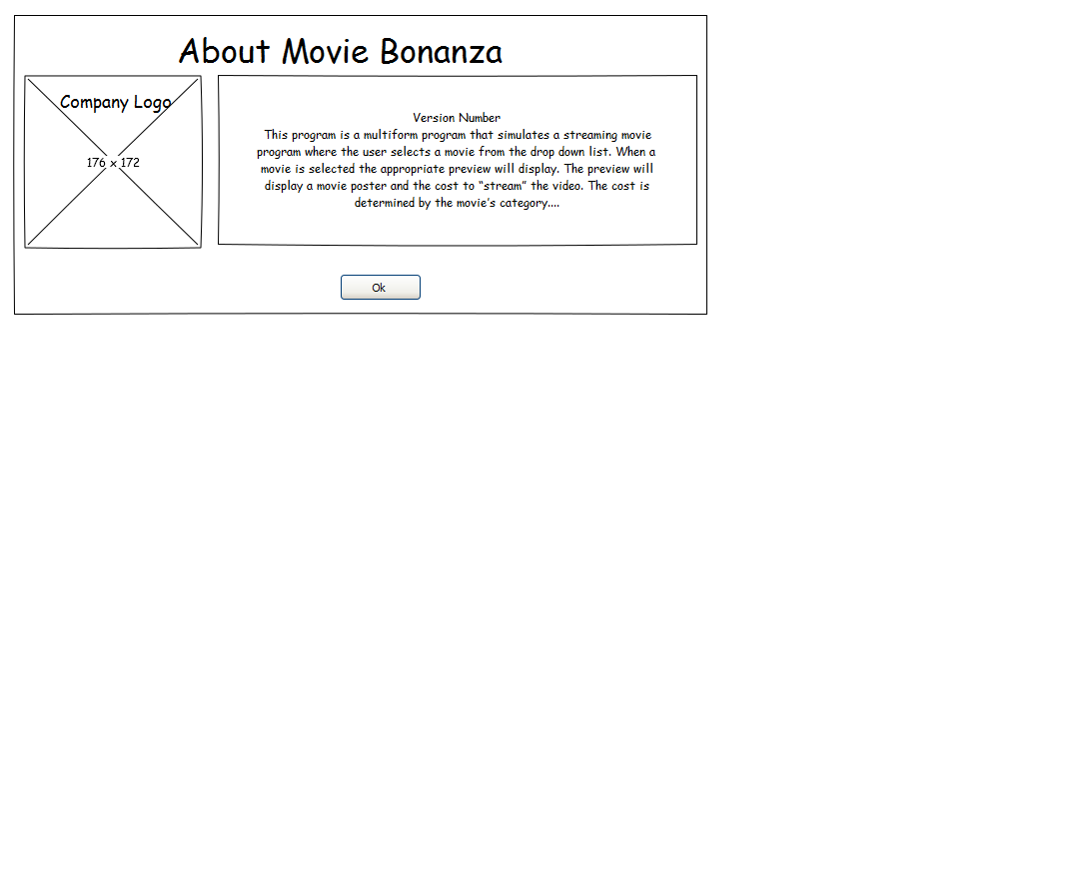

OrderForm

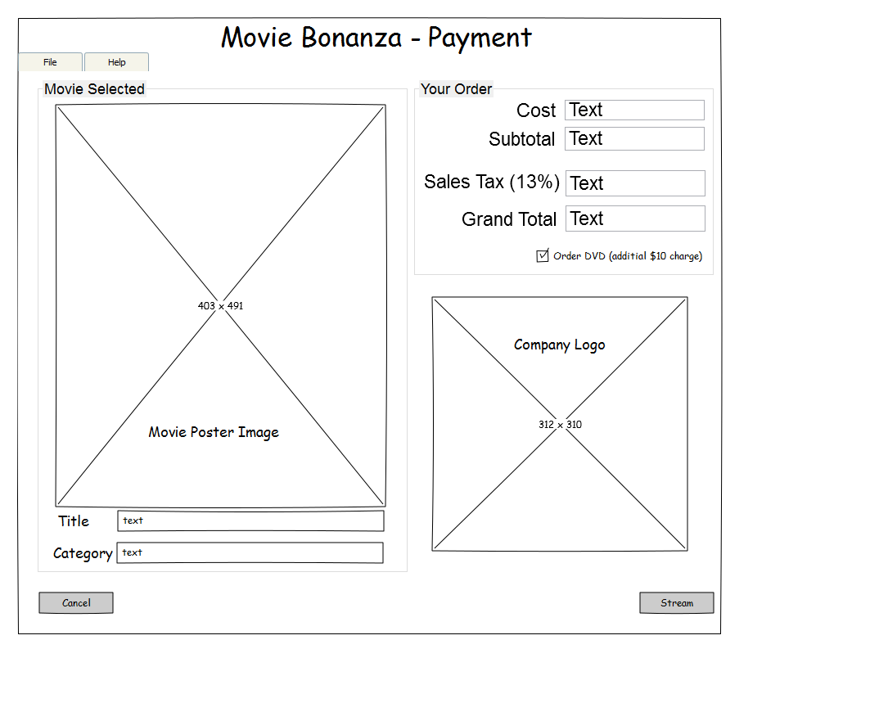

StreamForm

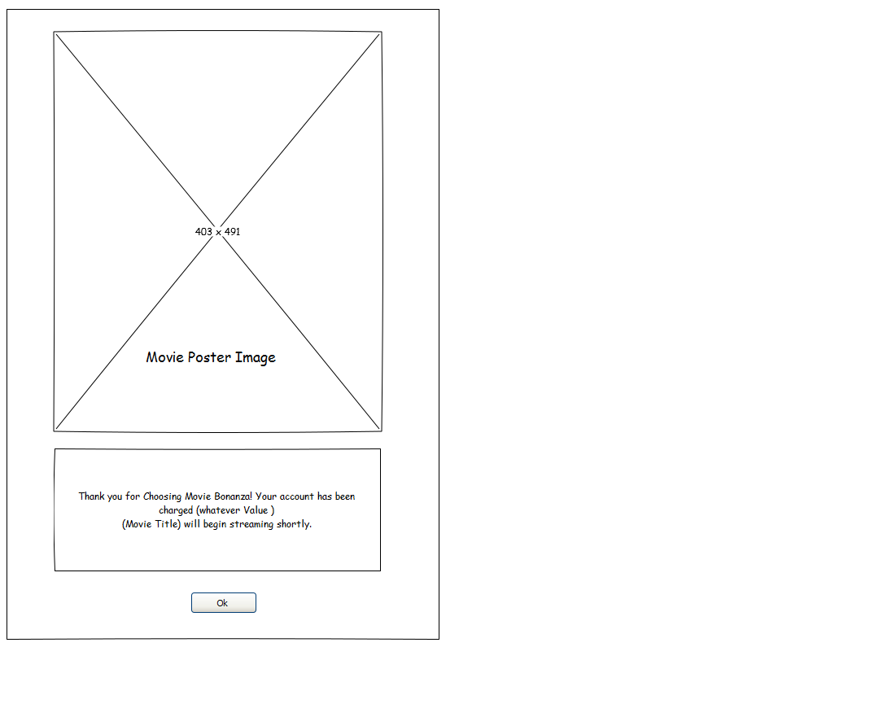

|  |  |  |
| --- | --- | --- |
| **Object** | **Property** | **Setting** |
| All forms | StartPosition | CenterScreen |
|  | Font | Microsoft Sans Serif, 14pt |
|  | Background color | Black |
|  | ForeColor | White |
| All forms except AboutBox | Control Box | False |
|  | Minimize, Maximize, Show Icon | False |
| All Forms textbox | readonly | true |
| All Forms GroupBox | BackgroundColor | Black |
|  | ForeColor | White |
|  |  |  |
|  |  |  |
|  |  |  |
|  |  |  |
|  |  |  |
|  |  |  |
|  |  |  |
|  |  |  |
|  |  |  |
|  |  |  |

# Code Planning:

*Form data passing*

Gather the selected values to pass. Set them into an array, in the order of name of movie, category, image file name, cost of the film and a message on whether or not a DVD has been ordered. Then pass them to the next form via public set methods. The current form also instances the next form and saves the memory location of the current form. Order Form and Stream Form are passed the previous form’s location in memory before the previous form hides and the current one loads.

*Selection Form*

This form reads an XML file for the movie selection data, parses through the file and assigns them to the multi dimension array. At the same time the movie names are stored in another array and sorted alphabetically. The movie name array is then loaded into the listbox in this form. Initially it loads a no movie image and empty text boxes. When a movie title is selected then the movie poster, title, category and initial price appears in appropriate places.

There is an exit button that closes the application if clicked.

The Stream button when clicked checks if an item from the listbox has been selected. If an item has been selected the selected values are passed into a passData array, the passData array passes the data to the next form. This form memory location is passed to Order Form where it is set by a set method in Order Form and this form hides while displaying the other one. If a movie has not been selected a message box warns the user that a movie has not been selected instead.

*Order Form*

When initiated this form creates the About Form and Steam form. Displays the selected movie information of title, cost, and category and movie poster. It then parses the cost data from string to decimal and calculates the subcost, tax and grand total cost.

This form has a menu strip. In the menu strip there is file and help menu items. The file stream option shares the event of the stream button click. The file cancel option shares the cancel button. The file print option prints the form to preview. The help about option opens the About Form as a dialog.

In this form there is a calculatePrice function. This function takes the cost string and parses it into decimal. From there if DVDcheckbox is checked then subcost = cost else it is subcost = cost + 10.00. Tax is calculated from subtotal * 0.13 and grand total is tax+subtotal. Each value is then displayed into the appropriate textbox.

On the form Activated event the calculatePrice function is called. When the DVDcheckbox is clicked the calculatePrice function is called. Then if the DVDcheckbox checked is true then the message on whether or not a DVD has been ordered is changed to “ and a DVD copy has been sent” else it is set to an empty string.

The Stream button changes the cost to equal the total calculated cost then passes movie data (name of movie, category, image file name, final cost of the film and a message on whether or not a DVD has been ordered.) in an array to Stream Form.

*About Form*

This form displays general information about the application. The application only has one function. Both the x button and OK button share an event that hides this form.

*Stream Form*

This form takes the picture data, movie title, cost data, DVD messaged data and displays the data. The picture data is displayed in a picture box. The movie title, cost and DVD message are formatted and displayed on the form activated and on the load event (shared event). The Okbutton closes the application.

# 

# Multi-Media:

Screen Shots:

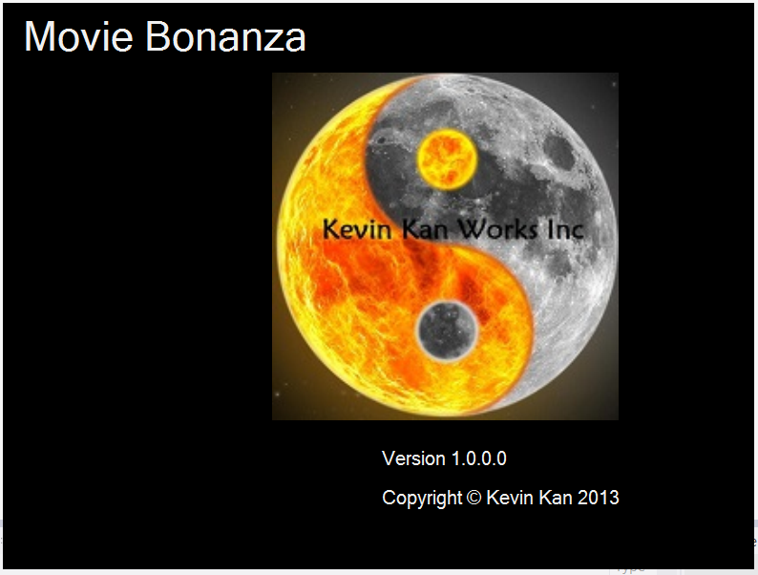Splash Page

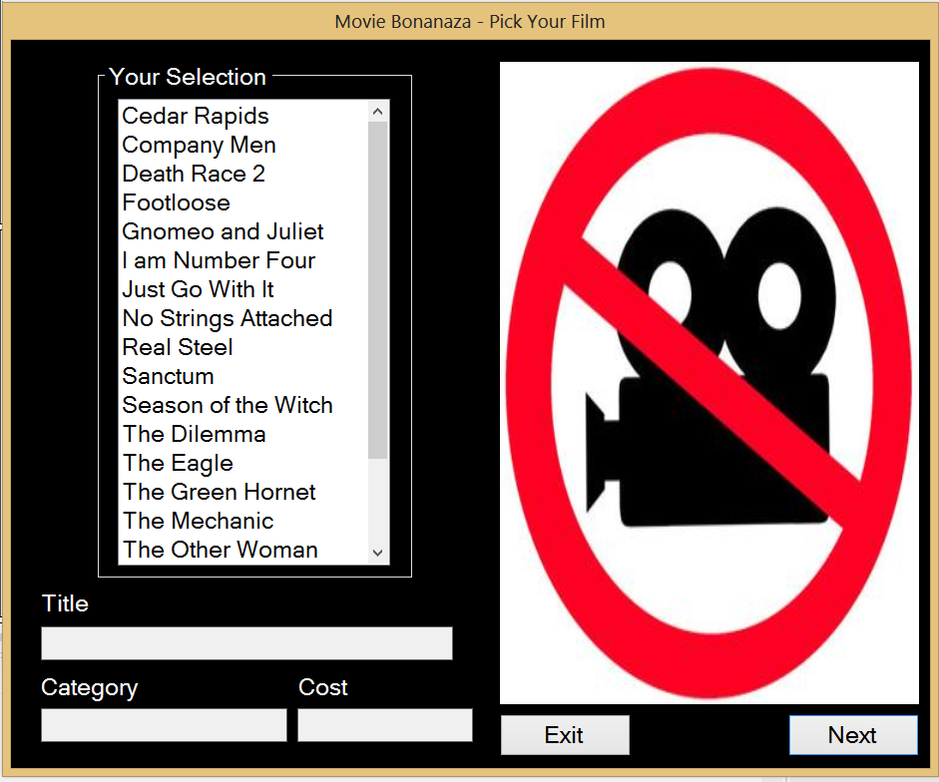Selection Form

Order Form

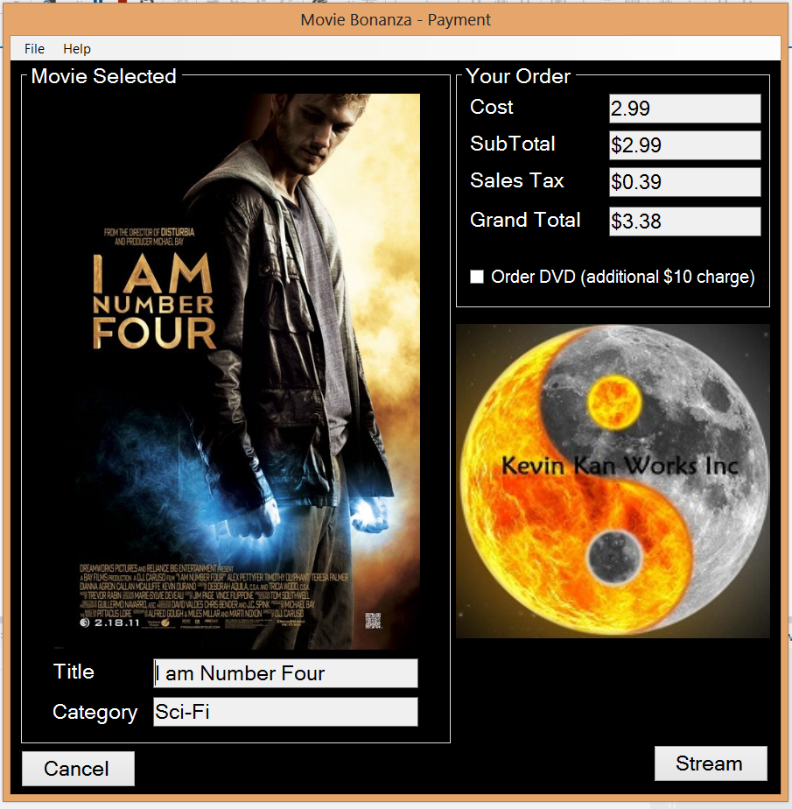

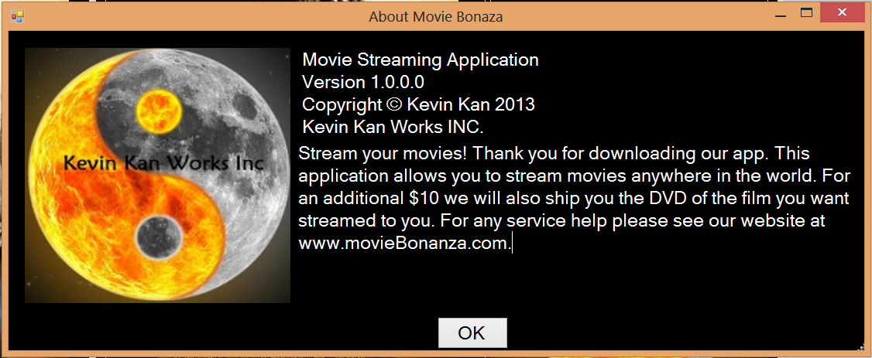About Box Form

Stream Form

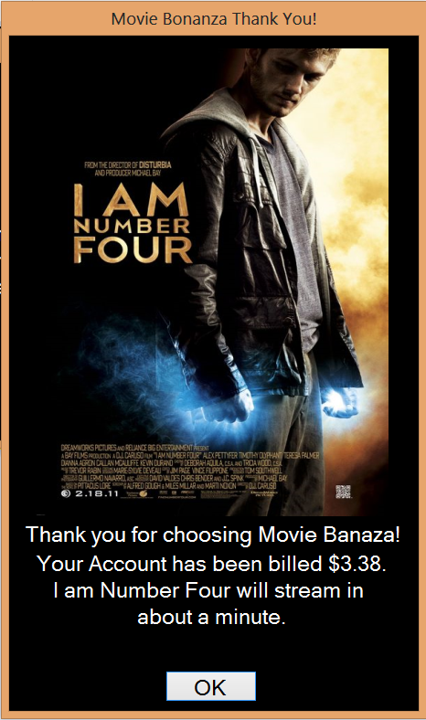

Logo: Yin Yang Symbol.jpg

Below this all images if not specified are movie posters for their respective films (the names on the poster) (Note none of the images below belong to Kevin Kan and are only used based on the basic educational purposes clause in copyright laws)

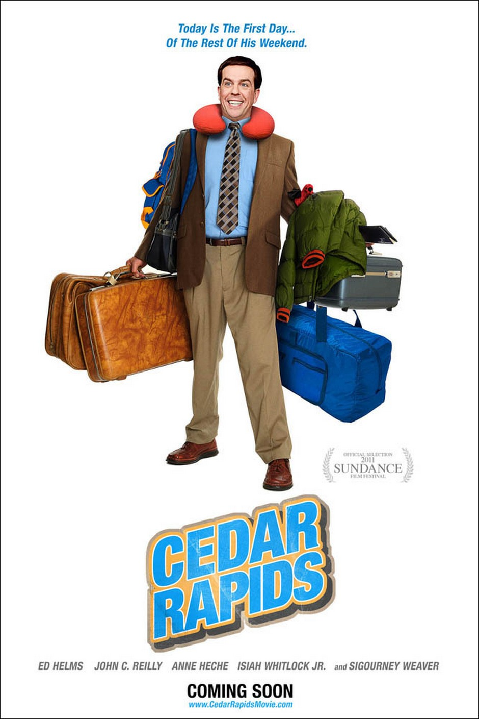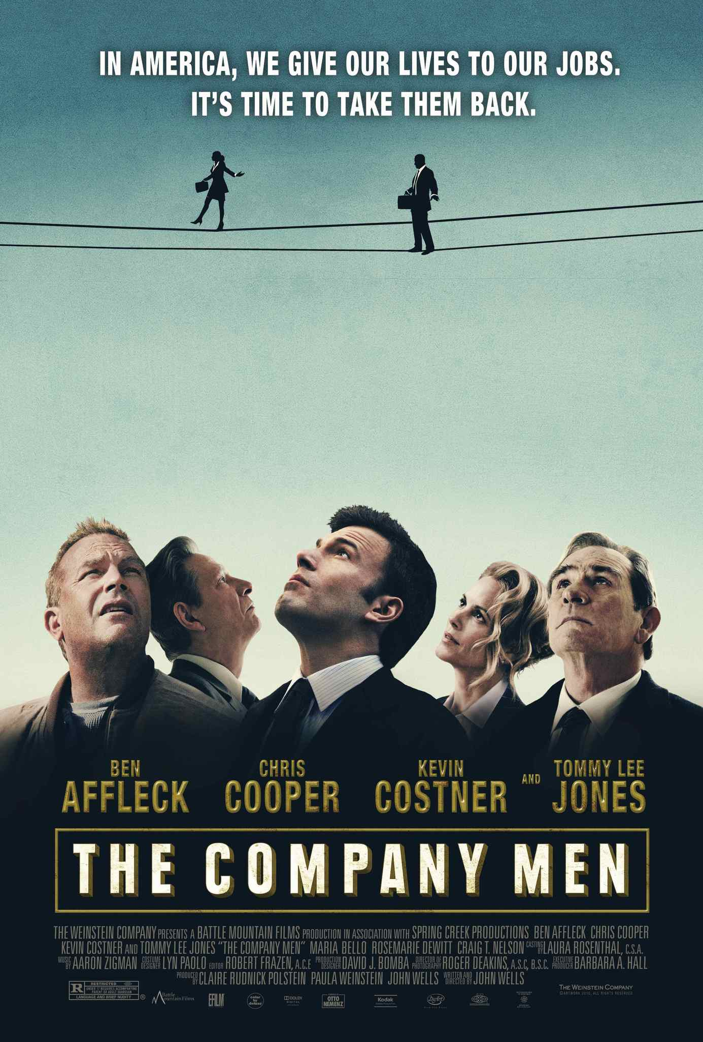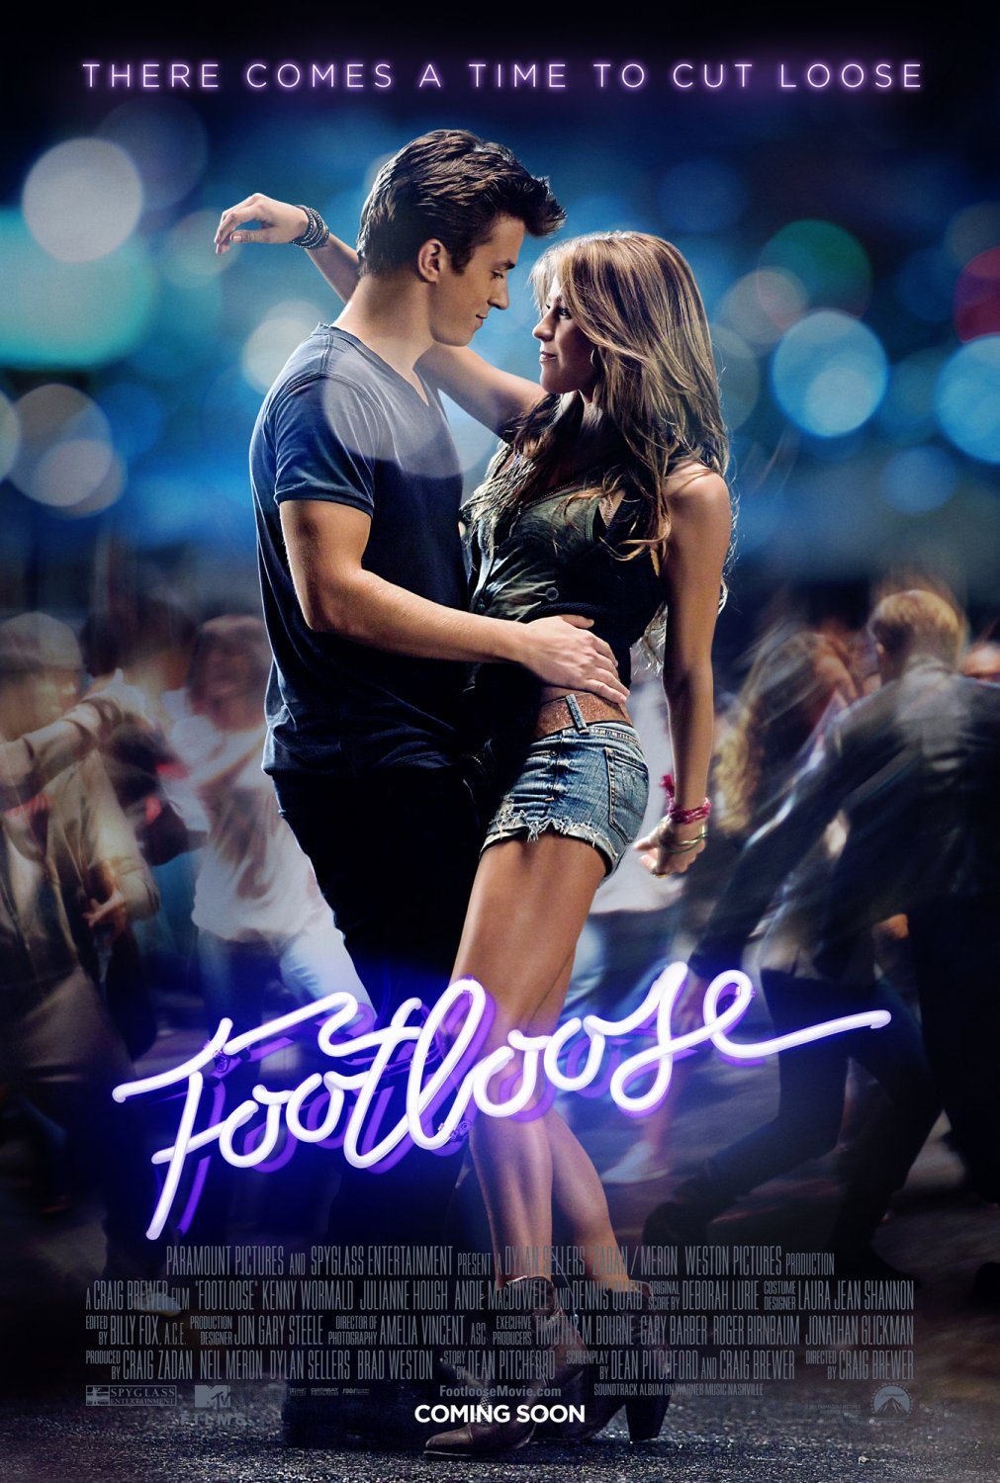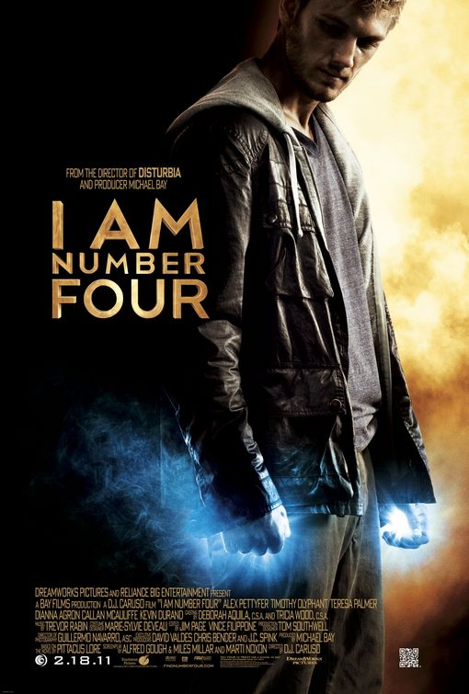

No Movie Image

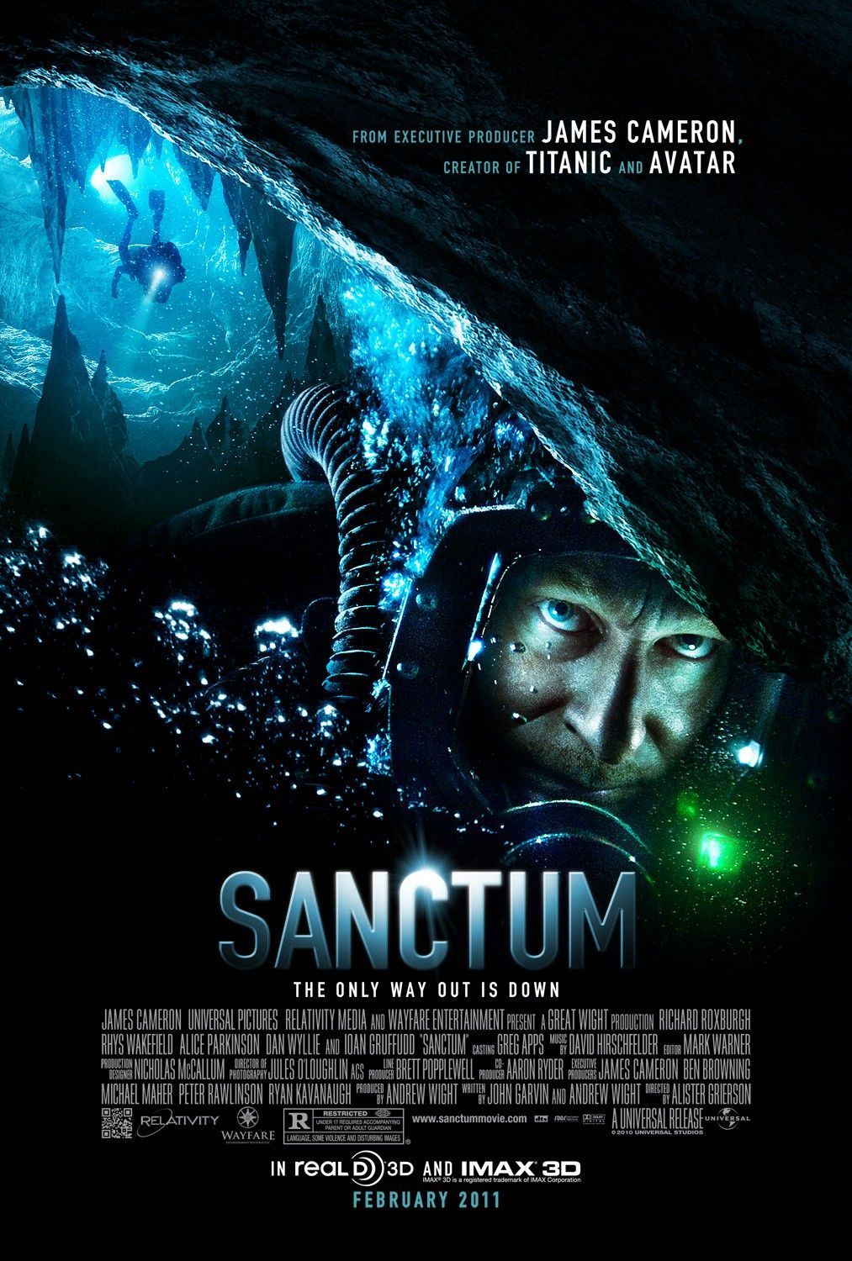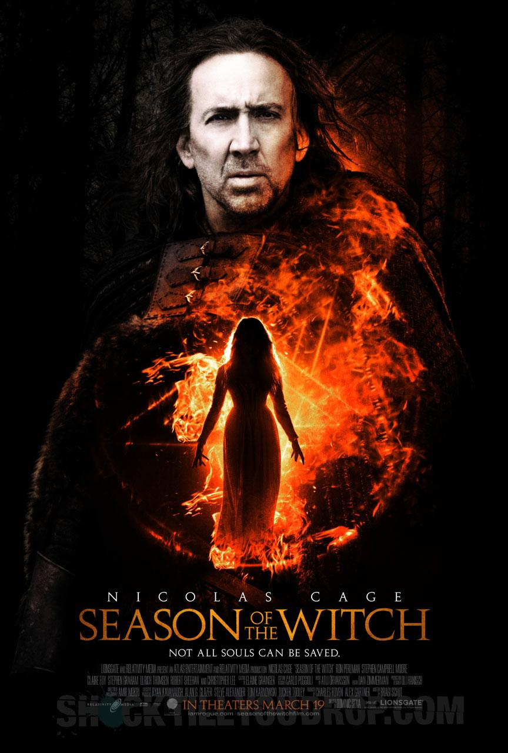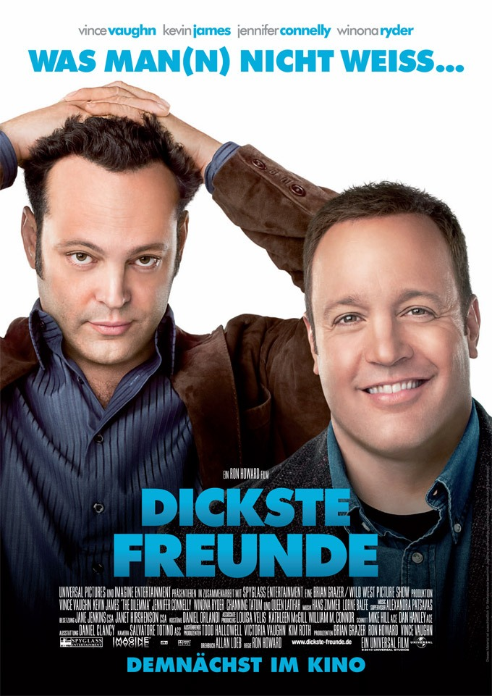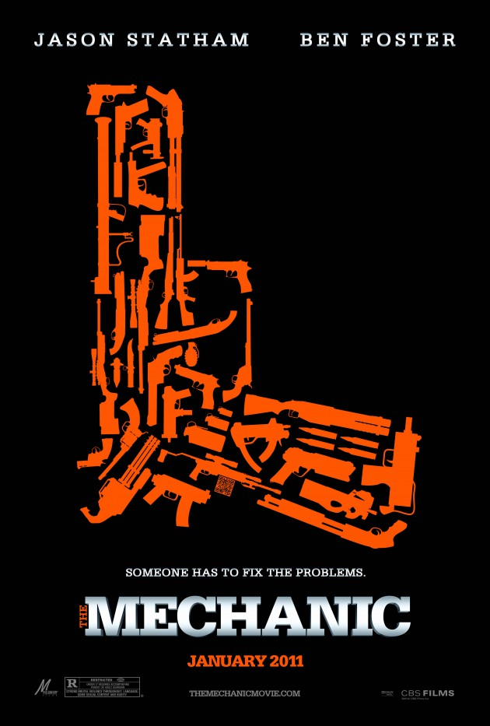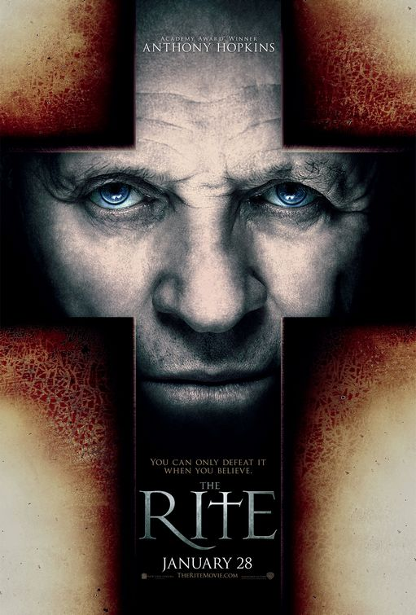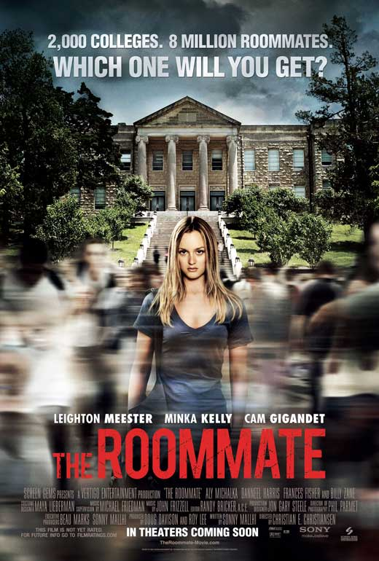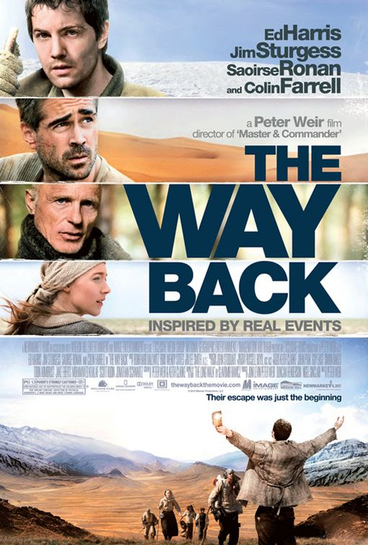

# Extra Additions

* Used XML to store all movie data and read into file
* All images dynamically changed via Properties.Resource.ResourceManager
* About box is purely the work of Kevin Kan.